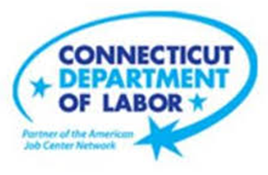

**NEW WEEKLY JOB POSTINGS FROM   
HELP WANTED ONLINE  
Office of Research**

**Week Ending February 12th, 2022: Total New Ads Down Slightly Over The Week**  
WETHERSFIELD, February 18th, 2022 – During the week ending February 12th, 2022, there were 7,315 new postings, down -635 ads over the week. Despite this overall decline, a majority of industries added jobs over the week, the largest being Accommodation & Food Services (+168 new ads), Pro., Sci., & Tech. Services (+115 new ads), and Finance & Insurance (+115 new ads). These gains were tempered by a large -1,355 over the week decline in Health Care & Social Assistance, which resulted in the net decline across all industries. There is some indication that this Health Care drop may be overstated as the result of a job ad deduplication issue within the HWOL series and not due to a large real drop in postings. Employers with the largest new ad increase and decrease over the week include Boston Market (+89 new ads) and Hartford Healthcare (-507 new ads). The first two weeks of February have averaged higher than the monthly averages for the previous two months, which includes the December-January Omicron covid case wave. The previous two months had much larger new ad ranges, with week to week shifts as large as 3,300 new ads  
  
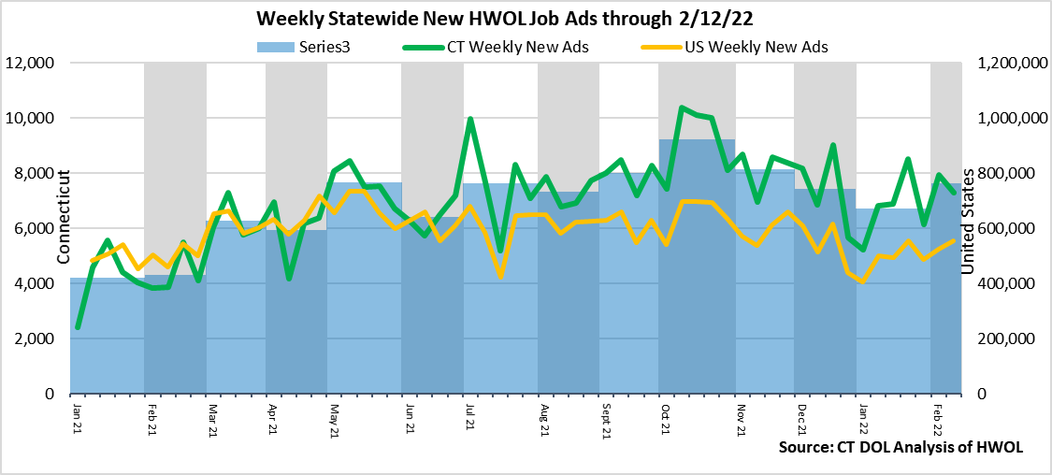

**Industries** with the most new postings include Health Care & Social Assistance, Retail Trade, and Finance & Insurance.

**Occupations** with the most new postings include Registered Nurses, Retail Salespersons, and Laborers & Material Movers.

**Employers** with the most new postings include Amazon, Hartford Healthcare, and Boston Market.

**The three industries with the most new job postings where:**

* **Health Care & Social Assistance** (1,530 new postings, -47% over the week)
* **Retail Trade** (826 new postings, +3% over the week)
* **Finance & Insurance** (771 new postings, +7% over the week)

   
 13 sectors had job posting increases over the week, two were unchanged, and 6 had decreases. The 13 increasing sectors grew by a combined 816 new ads and the 6 decreasing sectors fell by a combined 1,451 new ads. Most of that combined 6 sector decline occurred in Health Care & Social Assistance, which was down 1,355 new ads. The comparatively high Healthcare & Social Assistance levels during the week ending February 5th likely stem from a single employer deduplication issue within the HWOL database and not market shifts. Among increasing industries, the largest over the week gains occurred within Accommodation & Food Services (+168 new ads), Pro. Sci. & Tech. Services (+115 new ads), and Finance & Insurance (+52 new ads). Over Four weeks, the largest industry increase occurred within Finance & Insurance (+588 new ads) and the largest decrease occurred in Retail Trade (-210 new ads).   
  
 For more information on total job ads by industry for Connecticut and its labor market areas, see the monthly report available here: <https://www1.ctdol.state.ct.us/lmi/hwol.asp>

**New Job Postings by Occupation** 

**The occupations with the most new postings were:**

* Registered Nurses (478 new postings, -65% over the week)
* Retail Salespersons (200 new postings, -17% over the week)
* Laborers & Freight, Stock, & Material Movers (162 new postings, +179% over the week)

**Employers with the Most New Job Postings** 

Employers with the most new job postings during the week were mostly in Health Care & Social Assistance, Retail Trade, and Finance & Insurance. The 25 employers shown above account for 18 percent of all new ads. Among the top 25 employers, 15 had over the week ad increases, one was unchanged, and 9 had decreases. The 15 increasing employers had a combined 374 new ads, and the 9 decreasing employers in the top 25 had a combined 658 new ads. The largest increasing employers over the week was Boston Market (+89 new ads), and the largest decreasing employer was Hartford Healthcare (-338 new ads). Over four weeks, 19 employers in the most recent top 25 had increases and 6 employers decreased, the largest increase occurred at Boston Market (+96 new ads) and the largest four-week decrease occurred at Amazon (-298 new ads).

**What is HWOL?**The **Conference Board Help Wanted Online**® Data Series (HWOL) measures the number of new, first-time Online job postings and jobs reposted from the previous month for over 16,000 Internet job boards, corporate boards and smaller job sites that serve niche markets and smaller geographic areas. To view more HWOL data, go to: <https://www1.ctdol.state.ct.us/lmi/HWOL2021.pdf>